**First create the product.json file**

{

"products": [

{

"id": "1719909357728",

"name": "Product 3",

"price": "600"

}

]

}

Using json-server run the product.json file

**json-server products.json**

**Create-react-app react-redux-toolkit-product-app-createasyncthunk**

**npm install @reduxjs/toolkit axios redux-logger react-redux**

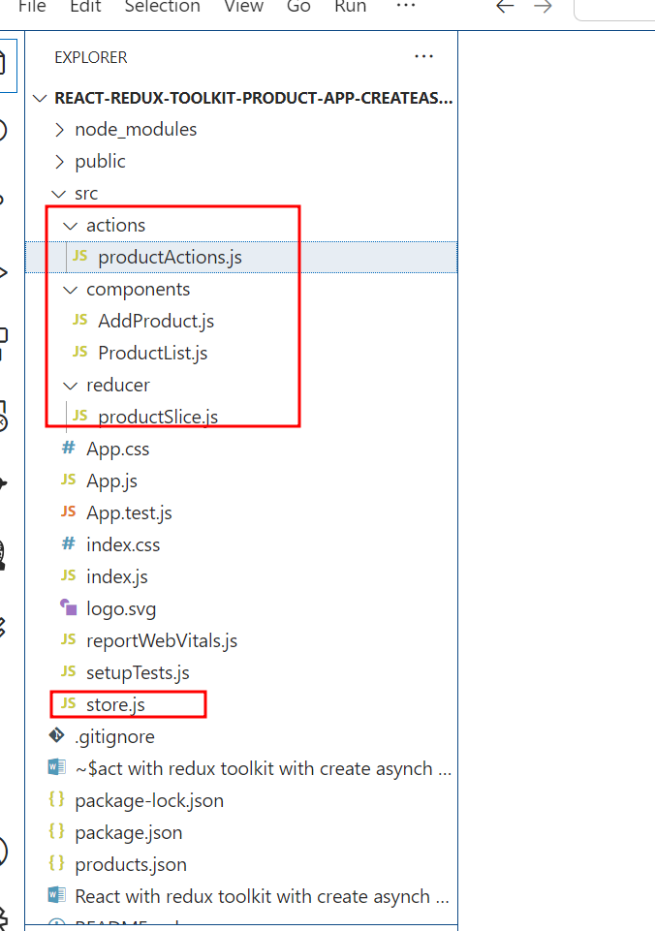

Please check the project structure

Create the reducer folder and create the **productSclice.js** file

import { createSlice } from '@reduxjs/toolkit';

const initialState = {

  productList: [],

  loading: false,

  error: null,

};

const productSlice = createSlice({

  name: 'products',

  initialState,

  reducers: {},

  extraReducers: (builder) => {

    builder

      .addCase('products/fetchProducts/pending', (state) => {

        state.loading = true;

        state.error = null;

      })

      .addCase('products/fetchProducts/fulfilled', (state, action) => {

        state.loading = false;

        state.productList = action.payload;

      })

      .addCase('products/fetchProducts/rejected', (state, action) => {

        state.loading = false;

        state.error = action.error.message;

      })

      .addCase('products/addProduct/pending', (state) => {

        state.loading = true;

        state.error = null;

      })

      .addCase('products/addProduct/fulfilled', (state, action) => {

        state.loading = false;

        state.productList.push(action.payload);

      })

      .addCase('products/addProduct/rejected', (state, action) => {

        state.loading = false;

        state.error = action.error.message;

      });

  },

});

export default productSlice.reducer;

**Now create the action folder and create the productActions.js file**

import { createAsyncThunk } from '@reduxjs/toolkit';

import axios from 'axios';

let url = "http://localhost:3000/products";

// Async Thunk for fetching products

export const fetchProducts = createAsyncThunk('products/fetchProducts', async () => {

  const response = await axios.get(url);

  console.log(response)

  return response.data;

});

// Async Thunk for adding a product

export const addProduct = createAsyncThunk('products/addProduct', async (productData) => {

  const response = await axios.post(url, productData);

  return response.data; // Assuming API returns the added product

});

export const hello = createAsyncThunk("hello",async()=> {

})

Now create the component folder and create two files as

**AddProduct.js**

import React, { useState } from 'react';

import { useDispatch } from 'react-redux';

import { addProduct } from '../actions/productActions';

const AddProduct = () => {

  const dispatch = useDispatch();

  const [productName, setProductName] = useState('');

  const [productPrice, setProductPrice] = useState('');

  const handleSubmit = (e) => {

    e.preventDefault();

    if (!productName || !productPrice) {

      alert('Please enter product name and price');

      return;

    }

    dispatch(addProduct({ name: productName, price: parseFloat(productPrice) }));

    setProductName('');

    setProductPrice('');

  };

  return (

    <div>

      <h2>Add Product</h2>

      <form onSubmit={handleSubmit}>

        <div>

          <label>Product Name:</label>

          <input

            type="text"

            value={productName}

            onChange={(e) => setProductName(e.target.value)}

            required

          />

        </div>

        <div>

          <label>Product Price:</label>

          <input

            type="number"

            value={productPrice}

            onChange={(e) => setProductPrice(e.target.value)}

            step="0.01"

            required

          />

        </div>

        <button type="submit">Add Product</button>

      </form>

    </div>

  );

};

export default AddProduct;

**ProductList.js**

import React, { useEffect } from 'react';

import { useSelector, useDispatch } from 'react-redux';

import { fetchProducts } from '../actions/productActions';

const ProductList = () => {

  const dispatch = useDispatch();

  const products = useSelector((state) => state.products.productList);

  const loading = useSelector((state) => state.products.loading);

  const error = useSelector((state) => state.products.error);

  useEffect(() => {

    dispatch(fetchProducts());

  }, [dispatch]);

  if (loading) return <p>Loading...</p>;

  if (error) return <p>Error: {error}</p>;

  return (

    <div>

      <h2>Product List</h2>

      <ul>

        {products.map((product, index) => (

          <li key={index}>

            {product.name} - {product.price}

          </li>

        ))}

      </ul>

    </div>

  );

};

export default ProductList;

create store.js file

import { configureStore,getDefaultMiddleware } from '@reduxjs/toolkit';

import productReducer from './reducer/productSlice';

import logger from 'redux-logger';

const store = configureStore({

  reducer: {

    products: productReducer,

  },

  middleware:(getDefaultMiddleware)=>getDefaultMiddleware().concat(logger),

  devTools:process.env.NODE_ENV !=="production"

});

export default store;

In App.js file add below code

import React from 'react';

import { Provider } from 'react-redux';

import store from './store';

import AddProduct from './components/AddProduct';

import ProductList from './components/ProductList';

const App = () => {

  return (

    <Provider store={store}>

      <div className="App">

        <AddProduct />

        <ProductList />

      </div>

    </Provider>

  );

};

export default App;

using npm start run the project

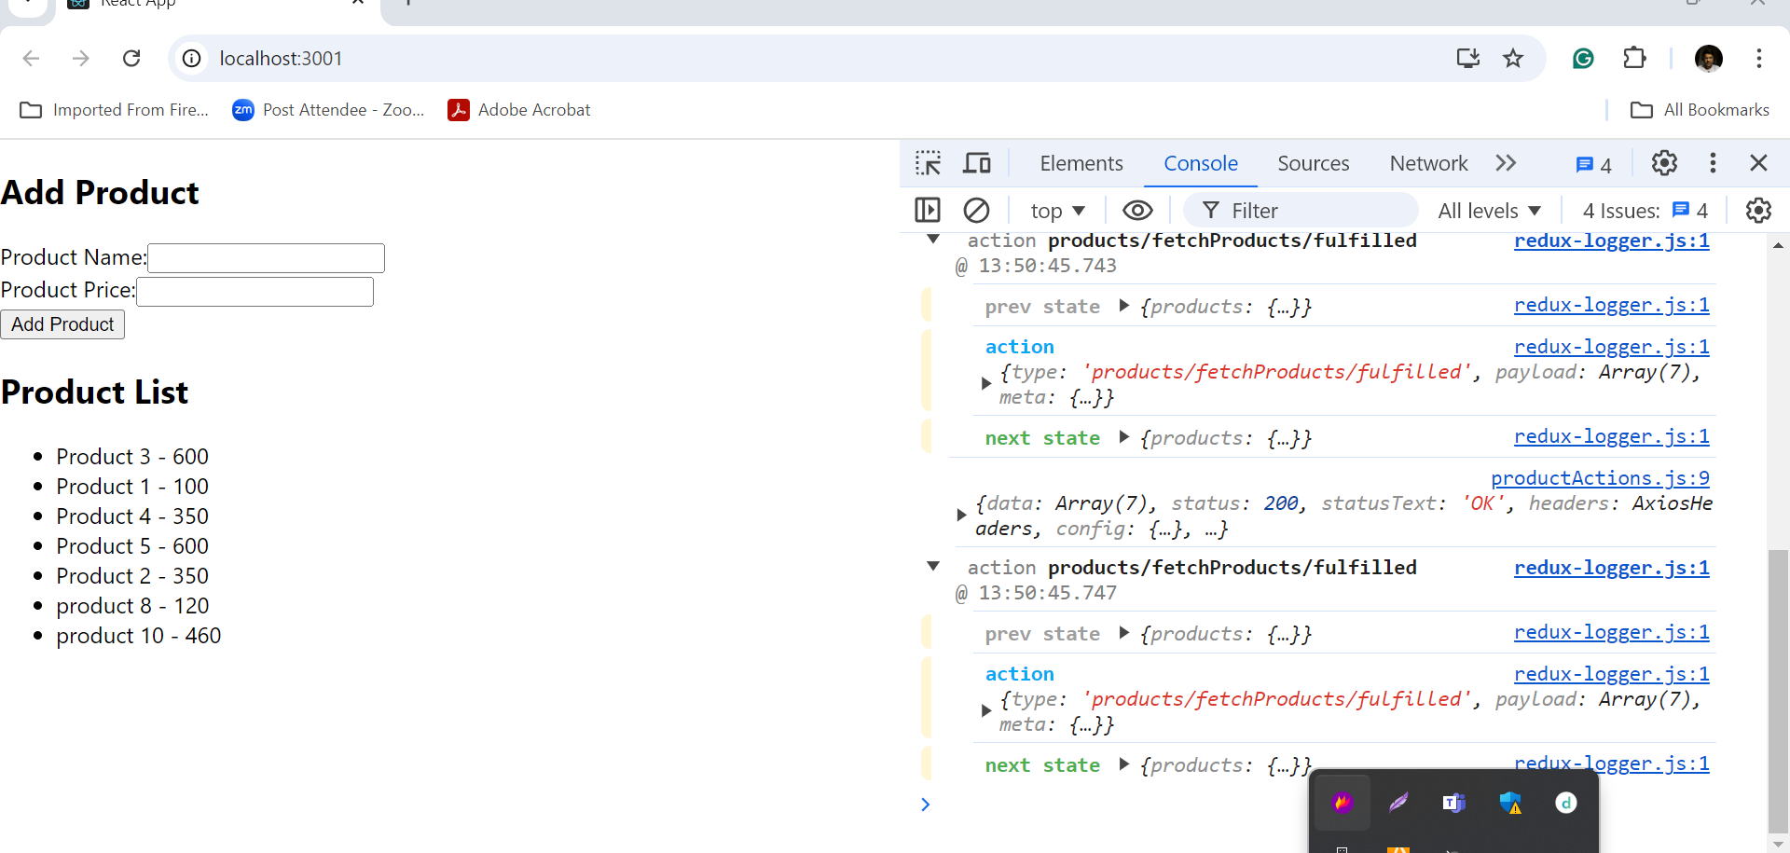

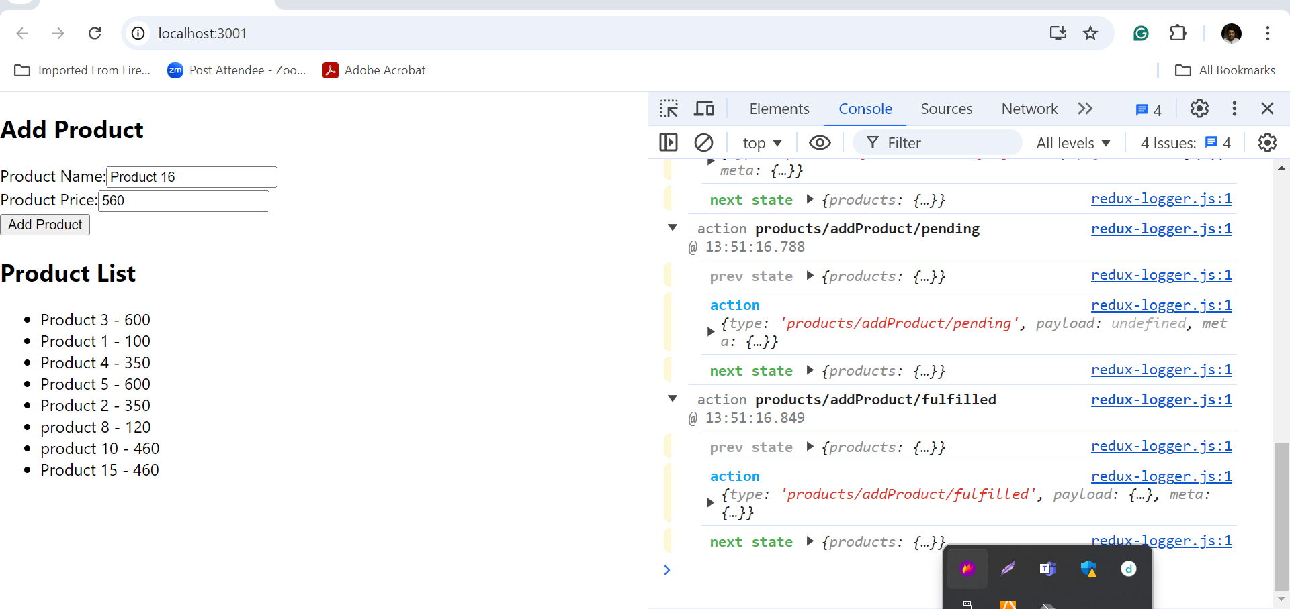

After added check the logger details also